**Chemical Ecology and Neurobiology of Mosquito Pollination**

Plant-pollinator interactions are chemically facilitated by floral odors, which mediates the coevolution of pollination systems. Here, I propose to study the Blunt-Leaved Rein Orchid, *Platanthera obtusata*, pollinated by Arctic *Aedes* mosquitoes (Fig. 1) to examine how chemical signaling changes as coevolved species diverge. Although mosquitoes are well studied as disease vectors, few studies have investigated their roles as pollinators. ***P. obtusata* one of two known mosquito-pollinated plants1 and it provides the unique opportunity to examine mosquito chemoreception in the context of pollination1.** In light of climate change and emerging mosquito eradication techniques, it has become increasingly important to understand the ecological interactions that involve mosquitoes to assess the collateral effects of such sweeping phenomena.

Figure 1: *Aedes* mosquito (♂) on *P. obtusata* with pollinia

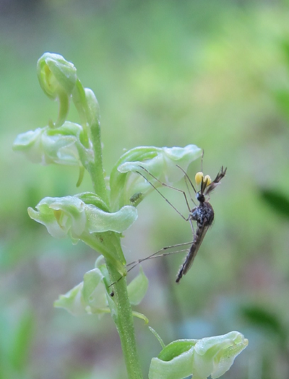

Both *P. obtusata* and Arctic mosquitoes, which span from Washington to Alaska2, are sympatric with other *Platanthera* species pollinated by bumblebees and moths3,4. Because of this sympatry, *P. obtusata* must maintain a “private channel” with mosquitoes to ensure pollen transfer to conspecific and not congeneric species. Other *Platanthera* species, such as *P. stricta* and *P. dilatata* are sympatric with *P. obtusata.* This hints that the mosquitoes should show a preference for *P. obtusata* floral scent. While working in the Riffell Lab, I analyzed the odors of other *Platanthera* species and observed a distinction in the chemical composition of the odors using the gas-chromatograph-mass-spectrometer in the Riffell Lab (Fig.2). We hypothesize that the floral scent compositions of the different *Platanthera* species will differ as implied by their different groups of pollinators. We hope to see if this separation can be seen with other multivariate analyses as well.

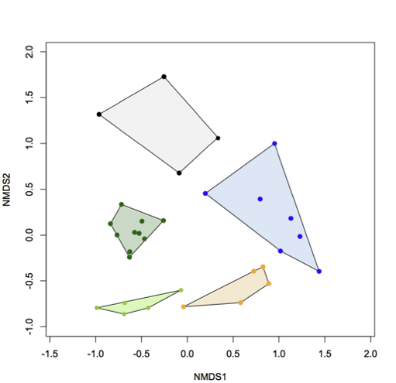

Figure 2: NMDS of *Platanthera* floral scent; stress = 3; Black – *P. stricta;* Blue – *P. dilatata*; Orange – *P. huronensis*; Greens – *P. obtusata*

References:

[1] Jhumur, Umma, Salma Dötterl, and Stefan Jürgens. "Electrophysiological and Behavioural Responses of Mosquitoes to Volatiles of Silene Otites (Caryophyllaceae)." *Arthropod-Plant Interactions* 1.4 (2007): 245-54.

[2] Thien, Leonard B. “Mosquito Pollination of Habenaria Obtusata (Orchidaceae).” *American Journal of Botany*, vol. 56, no. 2, 1969, pp. 232–237.

[3] Patt, JM et al. (1989) *Amer J Bot*

[4] Hapeman, JR and Inoue, K. (1996) *Cambridge University Press*.